Institute of Computer Technology

B. Tech. Computer Science and Engineering

Sub: DS Branch: BDA Class: A

Name: Jatin Patel

Enrolment No.: 23162121029

Sem: 3

Class: A

Subject: DS

Practical: 09

Date: 25/09/24

Write a program in C/C++ to create and display a Doubly Linked List.

Input data: 1, 6, 5, 9

Output: NULL > 1 > 6 > 5 > 9 > NULL

**Code:**

#include <stdio.h>

#include <stdlib.h>

struct Node

{

    int data;

    struct Node *prev;

    struct Node *next;

};

struct Node *createNode(int data)

{

    struct Node *newNode = (struct Node *)malloc(sizeof(struct Node));

    newNode->data = data;

    newNode->prev = NULL;

    newNode->next = NULL;

    return newNode;

}

void append(struct Node **head_ref, int data)

{

    struct Node *newNode = createNode(data);

    struct Node *temp = *head_ref;

    if (*head_ref == NULL)

    {

        *head_ref = newNode;

        return;

    }

    while (temp->next != NULL)

    {

        temp = temp->next;

    }

    temp->next = newNode;

    newNode->prev = temp;

}

void displayList(struct Node *head)

{

    struct Node *temp = head;

    printf("NULL");

    while (temp != NULL)

    {

        printf(" > %d", temp->data);

        temp = temp->next;

    }

    printf(" > NULL\n");

}

int main()

{

    struct Node *head = NULL;

    int numNodes, data;

    printf("Enter the number of nodes: ");

    scanf("%d", &numNodes);

    for (int i = 0; i < numNodes; i++)

    {

        printf("Enter data for node %d: ", i + 1);

        scanf("%d", &data);

        append(&head, data);

    }

    displayList(head);

    return 0;

}

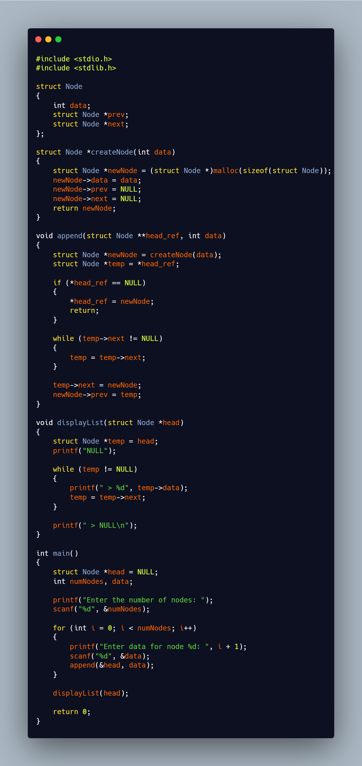

**Output:**

